Information Technology Policy
________________________________________________________________________________________________

Original effective date: | 5/7/2018
Date of last approval: | 5/20/2025
Approved by: | Executive Sponsor
Business unit: | HealthEquity, Inc.
Owner: | Executive Sponsor
Executive sponsor: | CTO

TABLE OF CONTENTS

1 PURPOSE AND SCOPE 2
2 Definitions 2
3 RESPONSIBILITIES 3
4 REQUIREMENTS 5
4.1 Acceptable Use 5
4.2 Data Security 5
4.3 Network Security 6
4.4 Software Management 6
4.5 Hardware Management 6
4.6 Incident Response 6
5 Technology Standards 6
6 Compliance and Enforcement 6
7 Policy Review 6

PURPOSE AND SCOPE
The HealthEquity, Inc. (“Company”) Information Technology Policy (“Policy”) sets forth the policies regarding information technology operations, services, and resources in the Company’s environment. This Policy applies to all Company systems, applications, or platforms used for storing, processing or transmitting information, including network and computer hardware, software and applications, mobile devices, across all Company working environments.

The goals of this Policy include the following:

- Define the roles, responsibilities, and critical elements for the efficient operations and support of the Company’s IT systems.
- Ensure the secure and efficient use of IT resources.
- Protect sensitive and confidential information.
- Comply with legal and regulatory requirements.
- Define the responsibilities of users and IT staff.

Definitions
When used in the context of this Policy, the following definitions apply.

Term | Definition
Asset | - Something with monetary value.
Change | - An alteration to our environment that has risk.
Configuration Item (CI) | - Configuration item, a single item in a CMDB.  - For example, a server, a piece of software, or a laptop.
CMDB | - Configuration Management Database.  - A centralized repository used to store information about the components of an IT system, known as configuration items (CIs).  - These items can include hardware, software, network devices, and documentation.
Disaster | - An incident usually involving multiple services.
Impact | - The measured, categorized severity and scope and incident has on business processes, services, or users.
Incident | - The unplanned loss or reduction in quality of an IT service.
Major Incident | - A high-impact, urgent issue that significantly disrupts business operations or affects a large number of users.  - The issue(s) involve critical services becoming unavailable, leading to substantial business impact, such as loss of revenue, reputation damage, or operational downtime.
Outage | - The planned or unplanned loss of a service.
Priority | - A value determined by impact and urgency.
Problem | - The underlying cause of one or more incidents.
Risk | - A combination of a negative event likelihood and its scope of impact are evaluated together to create a risk profile.
Root Cause Analysis (RCA) | - A step in the problem process to identify underlying issues responsible foran incident, and develop measures to prevent recurrence.
Service | - A value add to the company, a combination of people, process and technology.
Urgency | - The speed or velocity at which an incident needs to be resolved to minimized the negative effects on business operations.

RESPONSIBILITIES
The responsibility for Company information and systems is integrated into all aspects of the business. The roles and responsibilities in this section include all teammates, contractors, partners, and everyone engaged with the Company.

Role | Responsibilities
CTO | The Technology Leadership represents the CTO position and is responsible for:  - Product strategy and vision.  - Technology roadmap and execution.  - Review and approve policies.  - Establish and oversee the department‐wide information operations, service management, experience, and architecture programs.  - Establish and sponsor processes and procedures.
CIO | The IT Leadership represents the CIO position and is responsible for:  - Make executive decisions regarding matters such as the purchase of IT equipment or services from suppliers or the creation of new IT systems.  - Set objectives and strategies for the IT department.  - Review and approve IT policies.  - Establish and oversee the department‐wide information operations, service management, experience, and architecture programs.  - Establish and sponsor IT processes and procedures.
Configuration Item (CI) Manager | - Responsible for the attributes of a CI
Disaster Recovery Program Manager | Manage incident risk that impact business services. This process ensures that business services are available by reducing the risk from disaster events and planning for the recovery of business services.  - Disaster Recovery testing of key platforms, as identified in the Company’s Business Continuity Plan, are conducted regularly.  - Results of Disaster Recovery test are treated as Restricted Data and secured appropriately.  - Standards and Procedures should be published for Company [internal] use.
Engineering | Oversee the different IT services working with other professionals to troubleshoot issues and implement new IT services. Engineering may be involved in all aspects of the services in an organization, including planning, designing, implementing, troubleshooting, updating and repairing.  - Respond to, troubleshoot, identify, and solve system issues.  - Identify necessary improvements to systems.  - Configure and test systems and services.  - Own, manage, and update CIs within CMDB.
Enterprise Architecture | Strategic practice that involves planning, designing, and implementing enterprise-class solutions.  - Design the structure of technology systems.  - Determine appropriate solutions based on business need, such as software selection or workflow requirements.
Asset Management | - Asset management is the control of hardware and software assets throughout their lifecycle. Hardware and software assets shall be documented in the approved asset management system.  - Asset CIs are owned, updated, and managed by all company representatives, examples are a laptop, server, software, database, or network device.  - Standards and Procedures should be published for company [internal] use.
Change Management | - Change Management is a formal process for making alterations to IT services. Changes to production level systems shall be formally planned, requested, and approved prior to implementation.  - All Changes shall be logged.  - Standards and Procedures should be published for company [internal] use.
Incident Management | Incident Management ensures that any unplanned interruption to an IT service is managed through an established process. Incident Management shall ensure the establishment and maintaining of an Incident Response Team and an Incident Response Plan  - All Incidents shall be reported to the proper authority.  - All Incidents shall be logged.  - Standards and Procedures should be published for Company [internal] use.
Problem Management | Establishes clear guidelines and protocols for handling IT-related issues. This includes defining roles and responsibilities, establishing communication channels, and setting procedures for documentation and reviews. Problem Management shall include problem validation, development of alternative solutions, and trend analysis.  - Root Cause Analsys (RCA) reporting.  - All Problems shall be logged.  - Standards and Procedures should be published for Company [internal] use.
IT Operations Management | IT Operations Management ensures that IT systems and services meet Company standards and that monitoring, backup and recovery, are properly implemented to provide stability and security.  - Critical business platforms are monitored to detect errors and performance impact events.  - Where required, systems and data shall be backed up regularly and those backups validated as viable.  - Where required, systems and data shall be synchronized to ensure viable service.
Service Providers | Service providers include Operations Partners, contractors and entities that provide IT services to the Company.  - Maintain information technologies in support of Company’s business operations and policies as directed.  - Guarantee services meet SLAs as defined by the Company.  - Document work within the identified system
Teammate | A Teammate is a broad term used for all personnel that interact with information system resources either in a support function or by working directly with an information system user. For the purposes of this Policy, IT department Teammates include all employees and contractors, including Operations Partners and service providers.  Teammate responsibilities include the following:  - Comply with information technology policies, processes, and procedures and apply the principles to daily work activities.  - Assume accountability for protecting information technologies under their control in accordance with the policies.  - Report violations of the policies to the appropriate Leadership according to established procedures.  - Align technology services to the appropriate, approved technology standards and practices.  - Document work within the appropriate system

REQUIREMENTS
Information Technology (IT) provides computing services that are consumed by external partners, clients, and members, and internal groups, member/client services, People, Legal, etc. This Policy and related Technology Standards govern the Company’s IT services and help ensure a stable, predictable, secure, and cost-effective environment.

Acceptable Use
- General Use: IT resources are provided for business purposes. Personal use should be limited and must not interfere with work responsibilities.
- Prohibited Activities: Users must not engage in activities that are illegal, unethical, or that could harm the company's reputation or IT infrastructure.

Data Security
- Data Classification: All data must be classified according to its sensitivity (e.g., public, internal, confidential).
- Data Protection: Confidential data must be encrypted, and access must be restricted to authorized personnel only.
- Data Backup: Regular backups must be performed to ensure data integrity and availability.

Network Security
- Access Control: Network access must be controlled through authentication mechanisms such as passwords and multi-factor authentication.
- Monitoring: Network activity must be monitored to detect and respond to security incidents.

Software Management
- Software Installation: Only authorized software may be installed on company devices. Unauthorized software is prohibited.
- Software Updates: All software must be kept up-to-date with the latest security patches and updates.

Hardware Management
- Asset Management: All IT hardware must be inventoried and tracked.
- Maintenance: Regular maintenance must be performed to ensure hardware reliability and performance.

Incident Response
- Reporting: All security incidents must be reported immediately to the IT department.
- Response Plan: The IT department must have a documented incident response plan to address and mitigate security incidents.

Technology Standards
The CTO and CIO may approve Technology Standards to help implement this Policy.

Compliance and Enforcement
All users must comply with this Policy. Non-compliance may result in disciplinary action.

Policy Review
The policy owner will review this Policy annually.

Approval Certificate
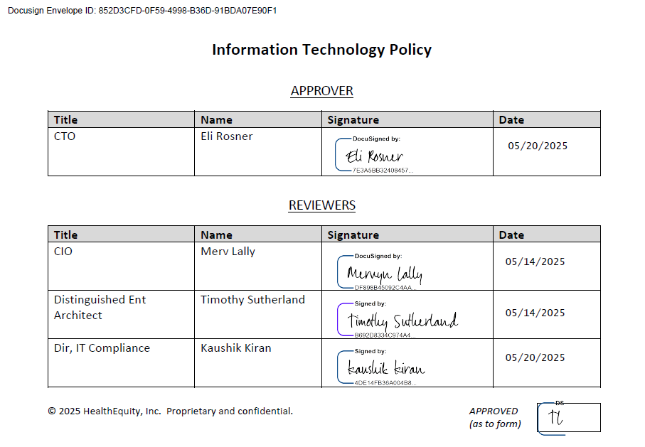

As defined in Section 4.1 of the Corporate Governance Policy.

